Beamtime Proposal for 6D UNIST-PAL Beamline

(2016-1st-Run: 2016-02-16 ~ 2016-05-05)
Principal Investigator |  | Department
Phone Number  (Mobile) |  | E-mail
Experimental Mode | XAFS ( ), SAXS ( ), GI-SAXS ( ), GI-WAXD ( )  X-ray Powder Diffraction ( ), Supramolecular Crystallography ( )  Protein Crystallography ( ),

1. Title

2. Abstract

3. Experimenters (Name / E-mail / Phone number)

4. How much beamtime you need (in days)?

5. Unacceptable Dates?

6. What equipment and conditions are required?

7. What equipment will you bring?

8. What is the scientific or technical purpose and importance of the proposed research?

9. Describe the participants' previous experience with synchrotron radiation and the experimental results obtained. (If you refer to previous publications, be sure to include complete citations.)

10. Describe the proposed experiment(s), including samples, required X-ray energy range and experimental procedures, and explain the basis for your estimate of the amount of beam time needed.

11. References

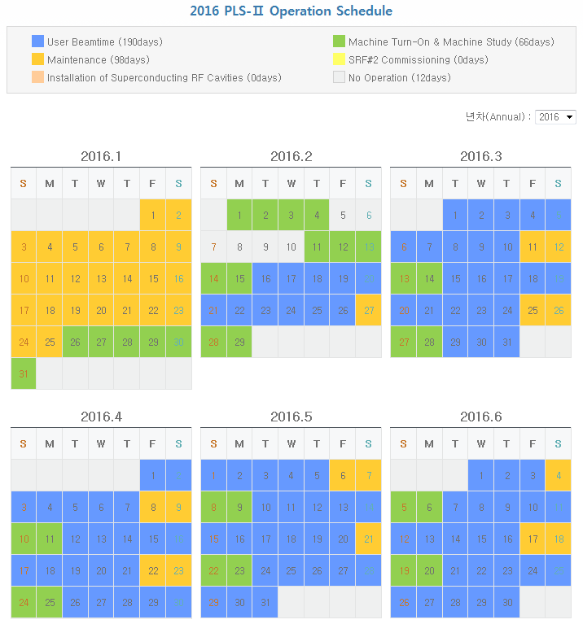
1. Schedule for 2016-1st-Run: 2016-02-16 ~ 2016-05-05
2. Experimental Modes

1) XAFS (X-ray Absorption Fine Structure) Spectroscopy

- Energy range: 5 ~ 20 keV (powder, liquid)

- in-situ experiment of Li-ion battery (coin cell, pouch cell)

- in-situ experiment of liquid sample (Transmission mode & Fluorescence mode)

- Multi-sample scan mode (Max. 15 samples)

- Thin film XAFS: PIPS detector, 7-element Ge Array Detector

2) SAXS (Small-angle X-ray Scattering), GI-SAXS

- SDD_{max}: 3.5 m, D_{max}: 150 nm

- Solution SAXS (Protein, polymer solution)

- in-situ Tr-SAXS (film, powder, polymer bulk, protein)

- in-situ cycling experiments of Li-ion batteries (coin cell, pouch cell)

- GI-SAXS: thin film (Heating/cooling)

- Multi-sample stage (static & in-situ experiments)

- in-situ film stretching up to 200 N, up to 350 ºC

3) WAXD (Wide-angle X-ray Diffraction), GI-WAXD

- Tr-WAXD (film, powder, polymer bulk, Heating/cooling, static)

- in-situ cycling experiments of Li-ion batteries (coin cell, pouch cell)

- High-pressure & High temperature XRD (@19 keV) (current 650 ºC, year 2016 1500 ºC

- GI-WAXD (thin film sample): OTFT, OLED, OPV, Heating up to 450 ºC

- in-situ experiment under Electric field (Up to 200 V)

- Multi-sample stage (static & in-situ experiments)

- in-situ film stretching up to 200 N, up to 350 ºC

- Powder XRD using capillary sample holder (sample rotation, heating up to 500 K)

4) X-ray Crystallography

- Supramolecular & protein crystallography

- Shutterless (continuous) Mode Experiment

- MAD & SAD experiments

- Temperature range: 100 ~ 500 K (within 30 min)

